SIMATS ENGINEERING

ASSESSMENT TOOL 1

COURSE CODE: CSA0706

COURSE NAME: COMPUTER NETWORKS

COURSE OUTCOME COVERED
CO2: Configure IP addressing schemes, subnetting, and basic routing techniques using simulation tool, for efficient network design and topology. (BL3)
Assessment Tool Weightage: 40%

Annexure A

ANALYTICAL PROBLEM SOLVING

Code of Conduct:

I RUCHITA.S ( 1 9 2 5 7 2 0 8 1) certify that this submission is my original work and that I have adhered to the guidelines specified for this assessment.
I understand that any violation of academic integrity rules will result in disciplinary action.

Signature of the student:

RUCHITA.(192572081)
Annexure A

ANALYTICAL PROBLEM SOLVING
- Suppose we want to transmit the message 11100011 and protect it from errors using the CRC polynomial X3+1.
i.) Use polynomial long division to determine the message that should be transmitted.
ii) Suppose the leftmost bit of the message is inverted due to noise on the transmission link. What is the result of the receiver's CRC calculation? How does the receiver know that an error has occurred?
SOLUTION:
Given
Message = 11100011, Generator polynomial G(x) = x³ + 1 → binary 1001 (4 bits, degree 3)

Part (i): Find the transmitted codeword
Step 1 — Append r = 3 zero bits (degree of G(x) = 3) to the message:
11100011 000 → 11100011000
Step 2 — Divide by 1001 using modulo-2 (XOR) division:
1 1 0 0 1 0 1 0 ← quotient (not needed)
-----------------------
1001 ) 1 1 1 0 0 0 1 1 0 0 0
1 0 0 1
--------
0 1 1 1 0
1 0 0 1
--------
0 1 1 1 1
1 0 0 1
--------
0 1 1 0 1
1 0 0 1
--------
0 1 0 0 0
1 0 0 1
--------
0 0 0 1 0
0 0 0 0
--------
0 0 1 0 0
Remainder (CRC) = 100
Transmitted codeword T = Message + CRC = 11100011 + 100 = 11100011100
(Verification: x¹⁰+x⁹+x⁸+x⁴+x³ divided by x³+1 leaves remainder x² =100)

Part (ii): Leftmost bit inverted — what does the receiver see?
- Original leftmost bit (position 1) = 1 → inverted to 0
- Received codeword: 01100011100
The receiver divides the received bits by the same generator 1001.
Since the error is a single-bit flip at the leftmost position, the error polynomial is E(x) = x¹⁰. Because x³ ≡ 1 (mod x³+1), we get x¹⁰ = (x³)³·x ≡ x, so:
Remainder = x → 010 (non-zero)
Conclusion: Because a valid, error-free codeword always divides evenly (remainder = 000), a non-zero remainder (010) tells the receiver an error has occurred, and the frame is discarded / retransmission is requested. (A single generator with more than one term, like x³+1, is guaranteed to detect any single-bit error.)

- a) A network with bandwidth of 10 Mbps can pass only an average of 12,000 frames per minute with each frame carrying an average of 10,000 bits. What is the throughput of this network?
b) A network has a bandwidth of 3000 Hz (300 to 3300 Hz) assigned for data communications. The signal- to-noise ratio is 3162. Find the channel capacity
SOLUTION:
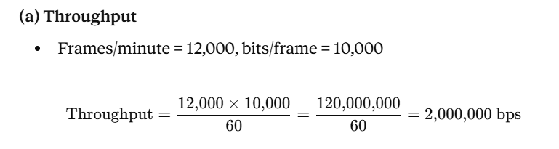
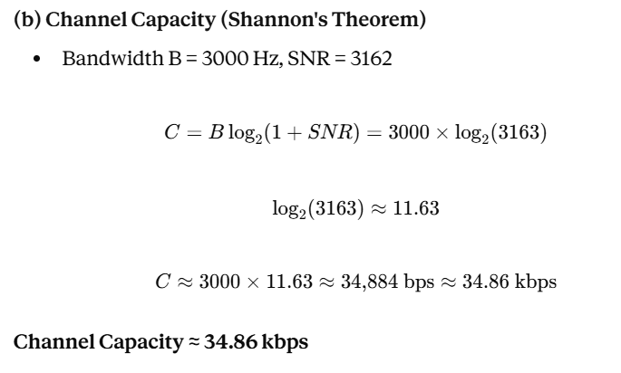
- A multispecialty hospital uses wireless patient-monitoring devices to continuously transmit patients' heart rate and blood pressure readings to a central monitoring station. Since the data is transmitted over a wireless channel, electromagnetic interference occasionally changes one bit during transmission. To ensure that doctors receive accurate patient information without waiting for retransmission, the hospital implements the Hamming (12,8) error-correcting code.
SOLUTION:
Why Hamming(12,8)? For 8 data bits (m = 8), the number of parity bits r must satisfy:
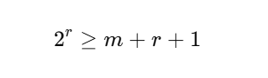
With r = 4: 2⁴ = 16 ≥ 8+4+1 = 13 → Total codeword length n = m + r = 12 bits, hence "Hamming(12,8)."
Bit layout (positions 1–12): Parity bits go in power-of-2 positions (1, 2, 4, 8); data bits fill the rest.
Position | 1 | 2 | 3 | 4 | 5 | 6 | 7 | 8 | 9 | 10 | 11 | 12
Bit type | P1 | P2 | D1 | P4 | D2 | D3 | D4 | P8 | D5 | D6 | D7 | D8
Each parity bit checks a specific set of positions (based on binary place value):
- P1 → positions 1,3,5,7,9,11
- P2 → positions 2,3,6,7,10,11
- P4 → positions 4,5,6,7,12
- P8 → positions 8,9,10,11,12

Worked example (illustrative patient-data byte = 10011010, i.e., D1..D8 = 1,0,0,1,1,0,1,0)
Computing each parity (even parity):
Parity | Checks | Data values | Sum | Parity bit
P1 | 3,5,7,9,11 | 1,0,1,1,1 | 4 (even) | 0
P2 | 3,6,7,10,11 | 1,0,1,0,1 | 3 (odd) | 1
P4 | 5,6,7,12 | 0,0,1,0 | 1 (odd) | 1
P8 | 9,10,11,12 | 1,0,1,0 | 2 (even) | 0
Transmitted codeword: 0 1 1 1 0 0 1 0 1 0 1 0

Error correction in action
Suppose interference flips bit 7 (0→... i.e., 1 becomes 0). Received: 0 1 1 1 0 0 0 0 1 0 1 0
The receiver recomputes each parity check (syndrome bits C1, C2, C4, C8):
Check | Positions | Values | Sum | Result
C1 | 1,3,5,7,9,11 | 0,1,0,0,1,1 | odd | 1
C2 | 2,3,6,7,10,11 | 1,1,0,0,0,1 | odd | 1
C4 | 4,5,6,7,12 | 1,0,0,0,0 | odd | 1
C8 | 8,9,10,11,12 | 0,1,0,1,0 | even | 0
Syndrome = C8 C4 C2 C1 = 0111 = decimal 7 → the error is at position 7.
The receiver flips bit 7 back (0→1), fully recovering the correct patient data without needing retransmission — exactly why the hospital chose Hamming(12,8): it self-corrects single-bit errors introduced by EM interference in real time, which is critical for continuous vital-sign monitoring.
- a) A company uses the IP address 172.16.10.0/24 and has implemented subnetting using a
/27 subnet mask for its internal departments. Using the given subnet mask, apply subnetting techniques to calculate the total number of subnets created and the number of usable hosts per subnet. Determine the subnet to which the IP address 172.16.10.78 belongs. Identify the network address and broadcast address for that subnet. Also, determine whether the IP address 172.16.10.95 falls within the same subnet range based on the given configuration.

b) A network uses the Internet Protocol version 6 address 2001:0db8:0000:0000:0000:ff00:0042:8329. Apply IPv6 addressing rules to compress the given address into its shortest form and then expand the compressed address back to its full
notation. Using a prefix length of /64, determine the network prefix of the given address. Also, calculate the total number of possible host addresses available within this network based on the given prefix length.
SOLUTION:

a) Subnetting: 172.16.10.0/24 → /27
- Borrowed bits = 27 − 24 = 3 → Number of subnets = 2³ = 8
- Host bits = 32 − 27 = 5 → Total addresses/subnet = 2⁵ = 32 → Usable hosts/subnet = 32 − 2 = 30
- Block size = 256 / 8 = 32
Subnet # | Network Address | Broadcast Address | Usable Range
0 | 172.16.10.0 | 172.16.10.31 | .1–.30
1 | 172.16.10.32 | 172.16.10.63 | .33–.62
2 | 172.16.10.64 | 172.16.10.95 | .65–.94
3 | 172.16.10.96 | 172.16.10.127 | .97–.126
4 | 172.16.10.128 | 172.16.10.159 | .129–.158
5 | 172.16.10.160 | 172.16.10.191 | .161–.190
6 | 172.16.10.192 | 172.16.10.223 | .193–.222
7 | 172.16.10.224 | 172.16.10.255 | .225–.254
172.16.10.78 → falls in Subnet 2 (172.16.10.64/27)
- Network address = 172.16.10.64
- Broadcast address = 172.16.10.95
Is 172.16.10.95 in the same subnet? Yes — it lies within the 172.16.10.64–95 range. However, note it is the broadcast address of that subnet, not an assignable host address.

b) IPv6 Addressing & Compression
Given Address:
2001:0db8:0000:0000:0000:ff00:0042:8329
Compression Rules Applied:
1. Rule 1 (Leading Zeros):* Omit leading zeros in any 16-bit block (0000 \right arrow 0, 0db8 \right arrow db8, 0042 \right arrow 42).

2. Expanding Back to Full Notation
Re-inserting omitted zeros into all 8 nibble groups gives:

3. Network Prefix & Total Host Addresses (/64 Prefix)
Network Prefix:* Take the first 64 bits (the first 4 blocks/hextets) and zero out the host portion:

Total Possible Host Addresses:*
* Host bits remaining = 128 - 64 = 64\text{ bits}
* Total addresses = 2^{64} = \mathbf{18,446,744,073,709,551,616} (over 18.4 quintillion addresses)

- A university is conducting an online semester examination for 8,000 students simultaneously. At exactly 10:00 AM, the examination server begins transmitting encrypted question papers to all students. The university server is connected through a 10 Gbps high-speed network, while students access the examination portal using different internet connections such as fiber broadband (100 Mbps), home Wi-Fi (20 Mbps), and mobile networks (5–10 Mbps). During the first few minutes of the examination, many students with slower internet connections report incomplete downloads, repeated retransmissions, delayed acknowledgments, and temporary freezing of the examination portal. Network administrators observe that the server continues transmitting data at a high rate even though several student devices are unable to receive and process packets at the same speed. This results in receiver buffer overflow, unnecessary retransmissions, increased network traffic, and delays in delivering the question papers. Analyze the above scenario and identify the primary networking problem. Explain how the mismatch between the sender's transmission speed and the receiver's processing capability affects communication.

SOLUTION:
The primary issue in this scenario is a Flow Control failure, exacerbated by severe Receiver Buffer Overflow and localized Congestion.
Specifically, Flow Control is the transport layer mechanism (managed by protocols like TCP) responsible for ensuring a sender does not transmit data faster than a receiver can process and store it.
While the situation also shows signs of network congestion due to 8,000 simultaneous connections, the specific symptom—where the server floods student devices beyond their processing capacity, leading to dropped packets at the destination—is a classic flow control mismatch.
Analysis: How the Speed Mismatch Affects Communication
The core issue stems from the vast discrepancy between the server’s capacity (10 Gbps) and the bandwidth/processing limits of individual client networks (5 to 20 Mbps).

[ University Server ]
│ 10 Gbps Connection
▼
┌─────────────────────────┐
│ High-Speed Core Network │
└────────────┬────────────┘
│
┌──────┴──────────────────────────────┐
│ Bandwidth & Processing Bottleneck │
└──────┬──────────────────────────────┘
│
┌───────────┼────────────────────────┐
▼ ▼ ▼
[Fiber] [Home Wi-Fi] [Mobile Network]
100 Mbp s 20 Mbps 5–10 Mbps
(OK) (Buffer Overflow) (Heavy Retransmissions)

1. Receiver Buffer Overflow
Every receiving device allocates a temporary memory region called a receiver buffer (or receive window) to store incoming network packets before the local application reads them.
The server sends packets at rates far exceeding what a 5 Mbps mobile or 20 Mbps Wi-Fi connection can ingest.
The client's buffer quickly fills up completely.
Once the buffer reaches 100% capacity, the client has no choice but to drop (discard) any incoming packets.
2. The Retransmission & Delay Cascade
When packets are dropped at the client's buffer:
Missing Acknowledgments (ACKs):The client fails to send ACKs for dropped packets.
Timeout & Retransmissions:The server assumes the packets were lost in transit and retransmits them.
Wasted Bandwidth: Retransmitting data that was already successfully sent over the core network duplicates traffic, worsening network congestion and locking up student portals.
3. Application Freezing & Unresponsive Portals
Because the transport layer is stuck re-ordering out-of-sequence packets and waiting for lost data, the web browser/portal application freezes. The student's device spends all its CPU cycles and memory trying to manage the incoming packet flood rather than rendering the exam questions.

Technical Solution
To resolve this, the university's network must properly utilize
TCP Flow Control Mechanisms:
Sliding Window Protocol: The client devices must continuously advertise a smaller Receive Window (RWIN) to the server. If a mobile device's buffer is filling up, it advertises RWIN = 0, signaling the server to temporarily stop transmitting until the client catches up.
TCP Congestion Control (e.g., Slow Start / CUBIC):The server must dynamically throttle back its transmission rate based on real-time packet-loss feedback per individual connection, rather than pushing data at maximum bandwidth to all 8,000 clients simultaneously.

RUBRICS FOR CALCULATION

Criteria | Weightage | Level 4 (Exemplary) | Level 3 (Proficient) | Level 2 (Developing) | Level 1 (Beginning)
Problem Understandin g | 20% | Clearly interprets problem, identifies all parameters and requirements accurately | Understands problem with minor gaps | Partial understanding  ; misses key elements | Misinterprets or unable to understand problem
Method Selection | 20% | Selects most appropriate  method/formul a with strong justification | Selects correct method with minor errors | Inappropriate or partially correct method | Unable to select method
Solution Process | 25% | Logical, systematic steps with correct approach throughout | Mostly correct steps with minor mistakes | Disorganized steps; multiple errors | No clear process
Accuracy of Calculation | 20% | All calculations accurate; correct final answer | Minor calculation errors | Frequent errors; incorrect final answer | No valid calculations
Interpretation of Results | 15% | Clearly interprets results with units and engineering relevance | Basic interpretatio n with minor omissions | Limited or unclear interpretation | No interpretatio n

